Visual Timetables

Background information
- A visual timetable uses photographs or pictures to show the daily routine of the setting - for young children photographs are easier to understand.
- Each different part of the day is represented by a clear photograph card.
- Using visual timetables is good practice for all children but especially helpful in helping children with additional needs to understand the order of the day.
- They especially help children who struggle to process and remember spoken language by giving a visual representation of what will be happening.
- Visual timetables are also useful in helping children that struggle to manage transitions between different activities – for example coming inside after outdoor play.

How to use a visual timetable in the classroom
- Use nice clear photos of your room. Pictures that do not include children are often easier for children to understand. Simple text labels help all staff to use the same names for each part of the day.
- Some children don’t yet recognise that pictures represent each part of the day - using objects of reference (e.g. a spoon to symbolise lunchtime) will be needed for these children.
- Useful cards may include carpet time, group time, play time, outside time, toilet time, lunch time, story time, singing time, home time.
- Ideally it will be at the children’s level so that they can easily access it. A5 size is ideal.
- Mini key-ring versions of the visual timetables for each member of staff. This makes it easier to show children what is going to happen next without having to walk across the room to get the appropriate card.
- You will need a ‘finished box/folder’ at the end of your visual timetable so that the cards can be removed from the timetable. This helps the children to keep track of what is happening now as it will be the first card that is on the timetable.
- Use the cards throughout the session with individual children that you feel will benefit from the visual support. For example, when it is snack time, take the snack time card over to the child and say ‘John, it’s snack time’ whilst pointing to the picture on the card. Keeping your language simple will help the child to understand what will be happening. Help the child to move to the new activity if needed. Reinforce once at the activity by again showing the card. Once the activity has finished the card can be put into the finished box/folder.
 | 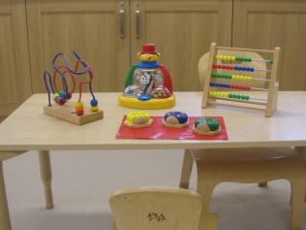  Play time | 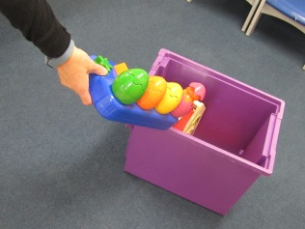  Tidy up | 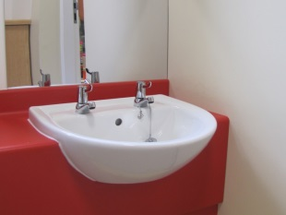  Wash hands | 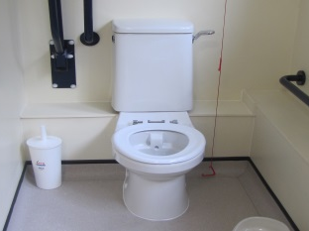  Toilet time

Useful websites & further reading
National Autistic Society website- http://www.autism.org.uk/~/media/nas/documents/living-with-autism/visual%20supports%20june%202013.ashx
ICAN website
https://ican.org.uk/media/1800/visual-timelines-factsheet-practitioners.pdf

