Developing Attention Skills

Background information
During our sessions at Hazel Trees we use an ‘attention bucket’ to help to develop these skills. This is a concept developed by Specialist Speech and Language Therapist, Gina Davies, as part of her Attention Autism programme.

Supporting Strategies
- You will need to begin by gathering suitable resources for your bucket. Highly visual and fun objects will help to gain the child’s attention and motivate them to engage in the session. Most of the resources we have in our bucket can be purchased for discount stores or from party supply shops. The objects should be kept in a small lidded bucket so that the children are intrigued in what will be used next.
- The session should take place in a quiet, distraction free environment – the adult with the bucket needs to be the most exciting thing in the room. At Hazel Trees we use a set of red step stools for the children to sit on during the bucket session – these act as a visual cue for what is going to happen. The children need to be seated in a small semi-circle facing the adult and the bucket. They need to be far enough away that they cannot touch the resources. This is not a turn taking activity, instead we want the children to all be focussing on the same thing, working on their shared attention skills. We want them to be able to shift their attention from the toy to the adult and back again, following the adult’s point and gaze and share in the adult’s enjoyment of the activity. They would not have to use such skills if they had a turn themselves.
- Ideally the group would involve around 6 children. If an additional adult is available they should join in alongside the children, modelling how to sit, facial expressions etc and to silently guide the children back to their seats should they get up.
- The routine of the session needs to remain constant and predictable. Gina uses a song to signal that bucket time is starting – ‘I’ve got something in my bucket, in my bucket, in my bucket, I’ve got something in my bucket, let’s look and see’ to the tune of ‘Polly put the kettle on’.
Pick an item from the bucket and close the lid. Look at the item and demonstrate what it can do, eg winding up and letting go a set of toy teeth. You need to use lots of facial expressions, surprise, excitement, etc to get the children engaged and enthusiastic. Model some keywords when, for example, winding up the teeth — “wind, wind, wind” — and when it has finished, ask the children “again/more?” Children can be encouraged to repeat the words and the other adults can also repeat them. You can use two or three short activities within the session and extend this as their attention improves. Change the items over in the bin regularly so that it continues to be exciting and motivating for the children.
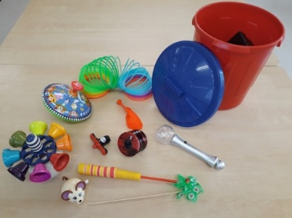

Useful websites & further reading
- http://asdteacher.com/attention-bucket/
- https://app.croneri.co.uk/feature-articles/bucket-therapy
- http://ginadavies.co.uk/parents-services/professional-shop/

